

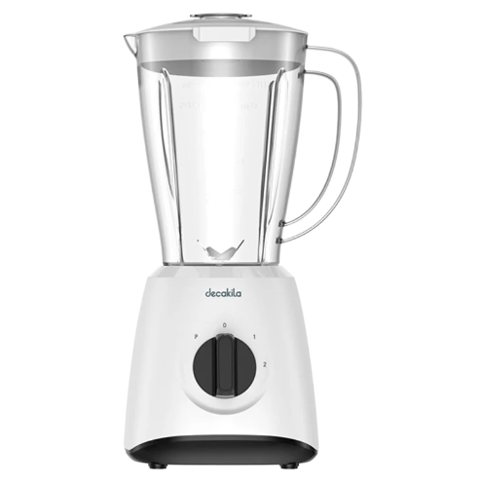

# Decakila KEJB001W Stand Blender

• Stainless steel blades

• 2 speeds control with pulse

• With plastic jug

• Anti-slip feet design